**NAME – KHUSHI PANWAR**

**ROLL NO – 2021334**

**PYTHON (DATA SCIENCE) ASSIGNMENT 2**

**\*LOOP PROGRAMMING\***

1. **Write a PYTHON to print all natural numbers from 1 to n – using while loop.**

n=int(input("Enter the value of n : "))

print("-> The natural numbers from 1 to n are : ")

i=1

while (i<=n):

    print(i)

    i+=1

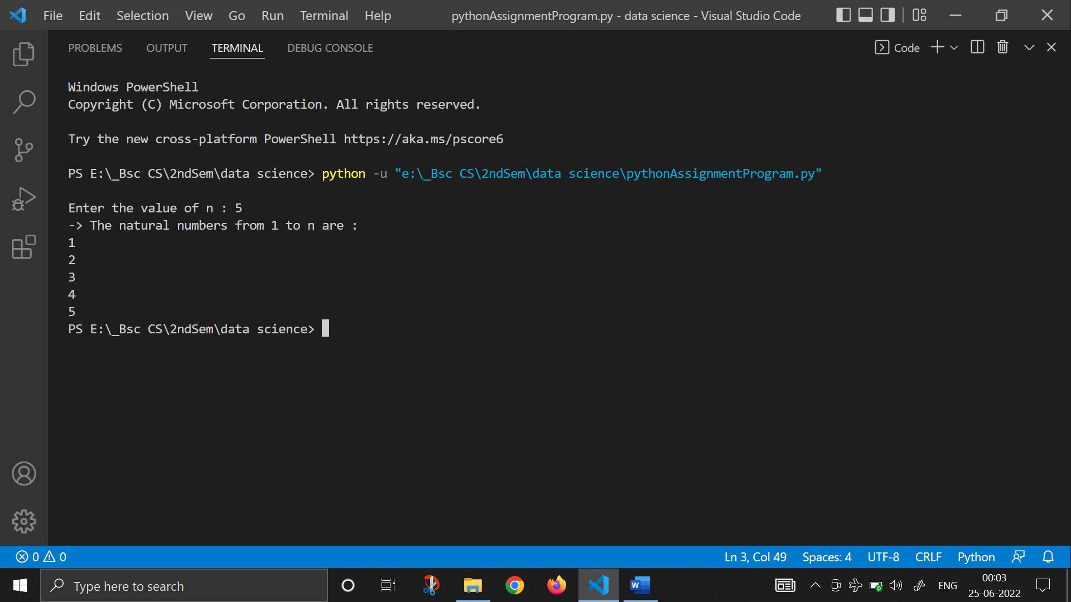

1. [**Write a program to print all natural numbers in reverse (from n to 1)**](https://codeforwin.org/2015/07/c-program-to-print-all-natural-numbers-in-reverse.html)**. - using**[**while loop**](https://codeforwin.org/2015/07/c-program-to-print-all-natural-numbers.html)

print()

n=int(input("Enter the value of n : "))

print("-> The natural numbers from n to 1 are : ")

i=1

while (n>=i):

    print(n)

    n-=1

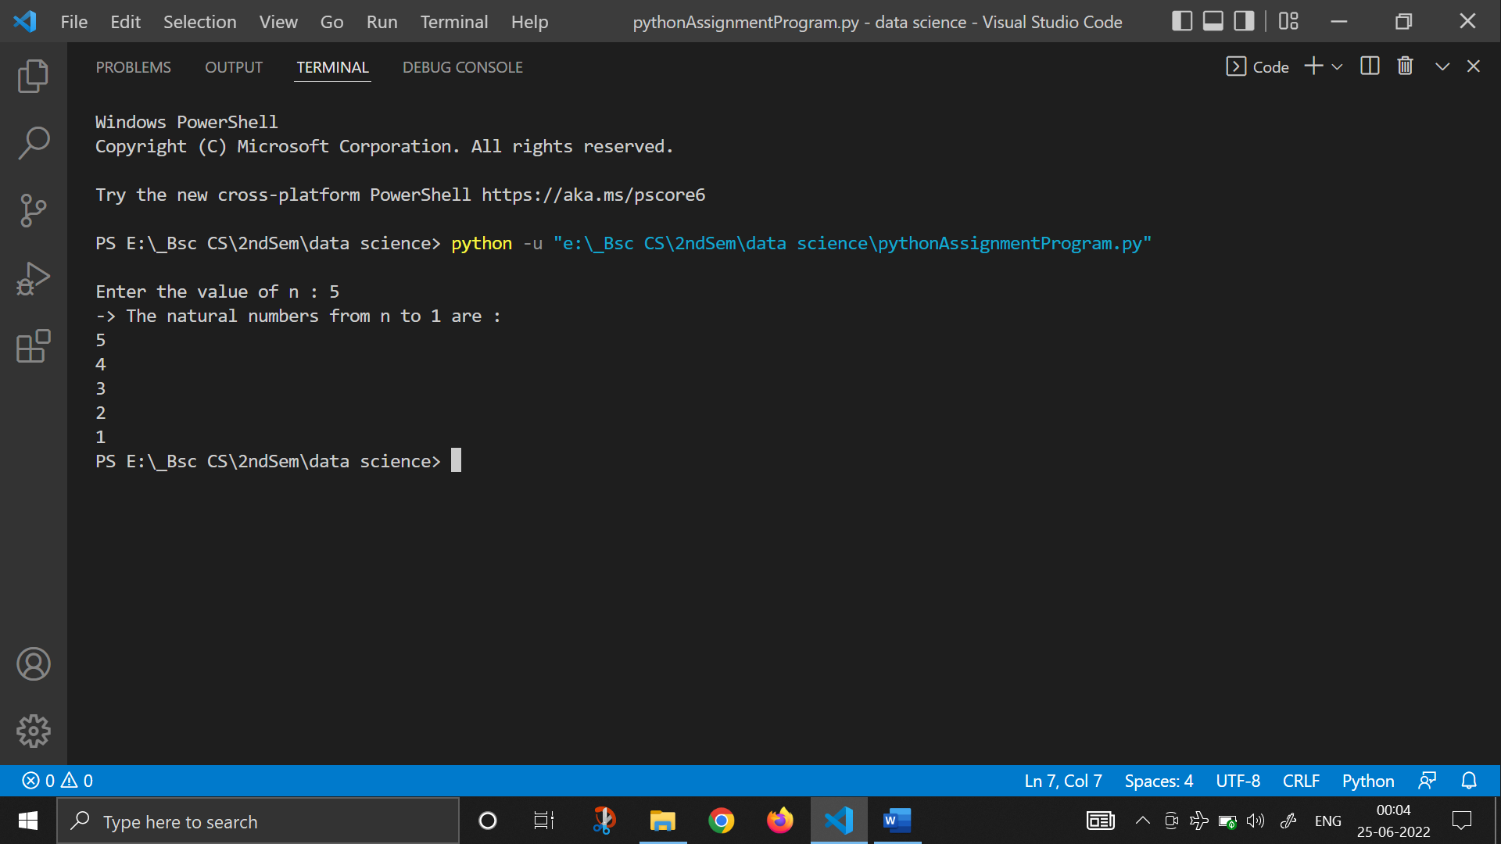

1. [**Write a program to print all alphabets from a to z.**](https://codeforwin.org/2015/06/c-program-to-print-a-to-z.html)**- using**[**while loop**](https://codeforwin.org/2015/07/c-program-to-print-all-alphabets-using-while-loop.html)

print("-> The alphabets from a to z : ")

i=ord('a')

while (i<=ord('z')):

    print(chr(i), end="\t")

    i+=1

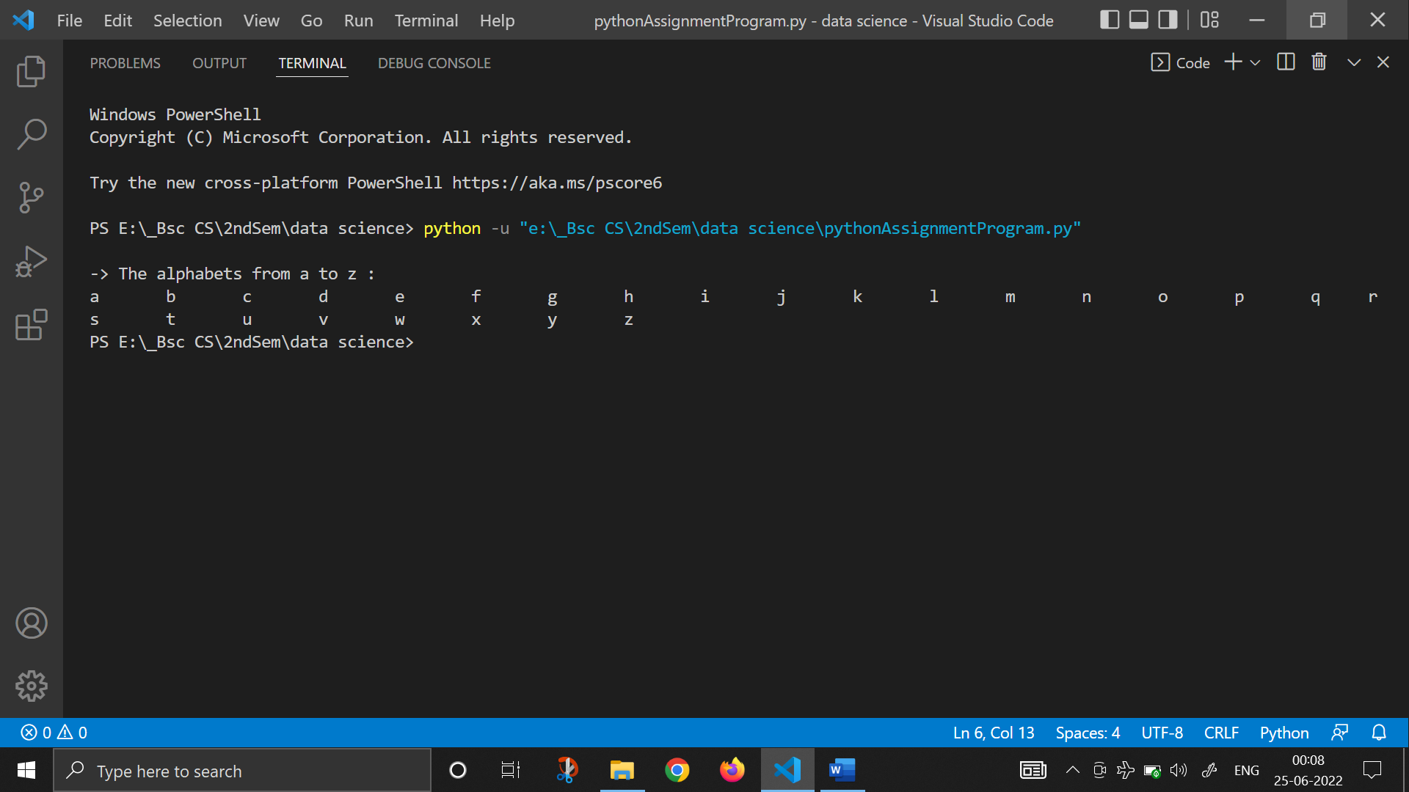

1. [**Write a program to print all even numbers between 1 to 100.**](https://codeforwin.org/2015/06/c-program-to-print-all-even-numbers-between-1-to-100.html)**- using**[**while loop**](https://codeforwin.org/2015/06/c-program-to-print-all-even-numbers-using-while-loop.html)

print("-> The Even Numbers between 1 to 100 are : ")

i=1

while (i<=100):

    if (i%2==0):

        print(i, end="\t")

    i+=1

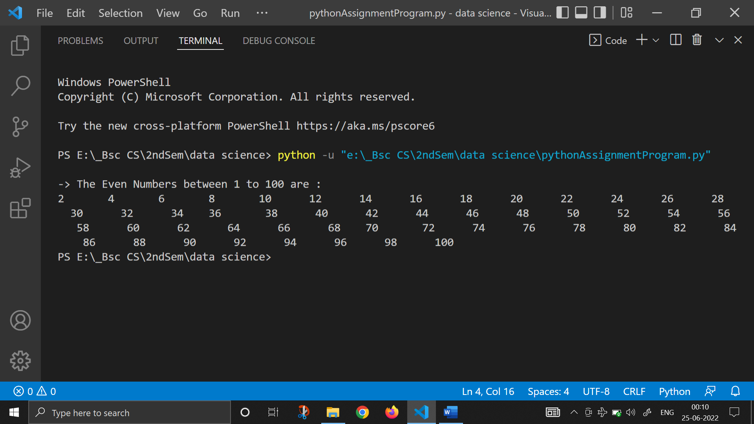

1. [**Write a program to print all odd number between 1 to 100.**](https://codeforwin.org/2015/06/c-program-to-print-all-odd--numbers-between-1-to-100.html)

print("-> The Odd Numbers between 1 to 100 are : ")

i=1

while (i<=100):

    if (i%2!=0):

        print(i, end="\t")

    i+=1

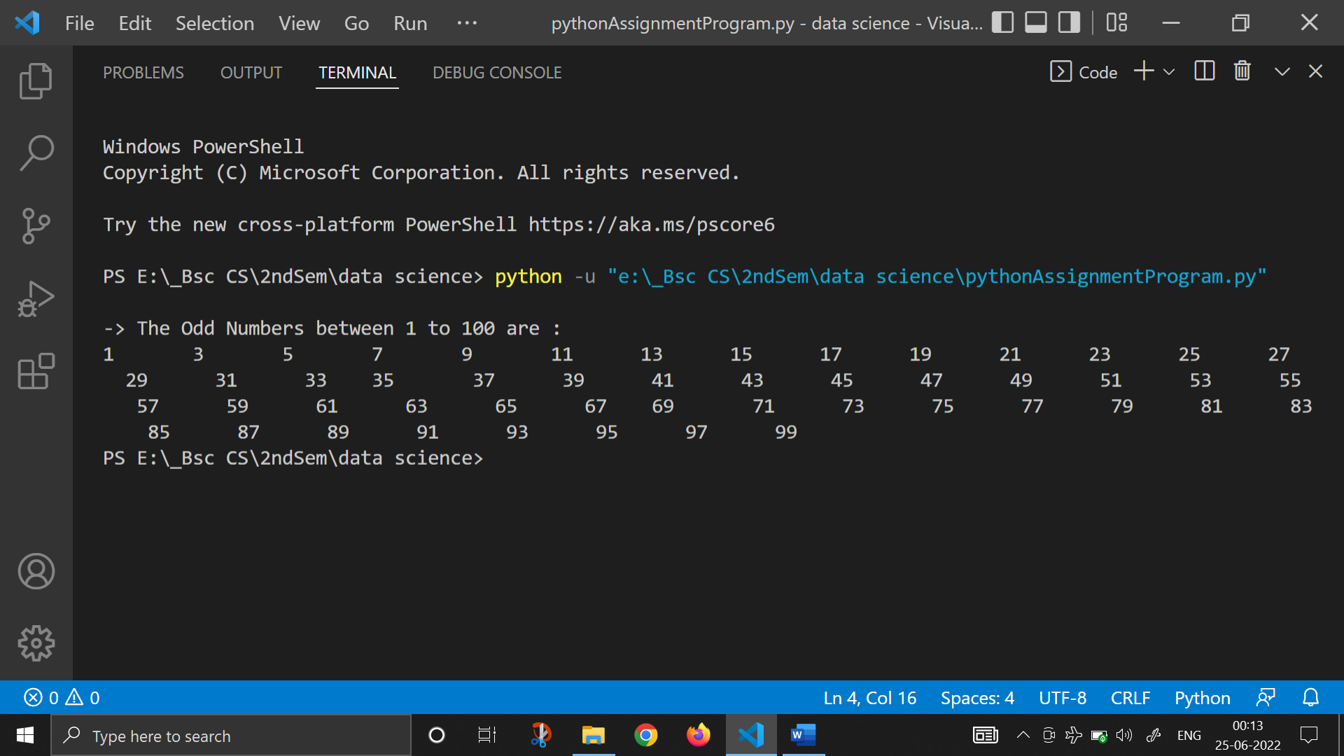

1. [**Write a program to find sum of all natural numbers between 1 to n.**](https://codeforwin.org/2015/06/c-program-to-calculate-sum-of-first-n-natural-numbers.html)

n=int(input("Enter the value of n : "))

sum=0

i=1

while (i<=n):

    sum+=i

    i+=1

print("-> The Sum of all natural numbers from 1 to n is : ", sum)

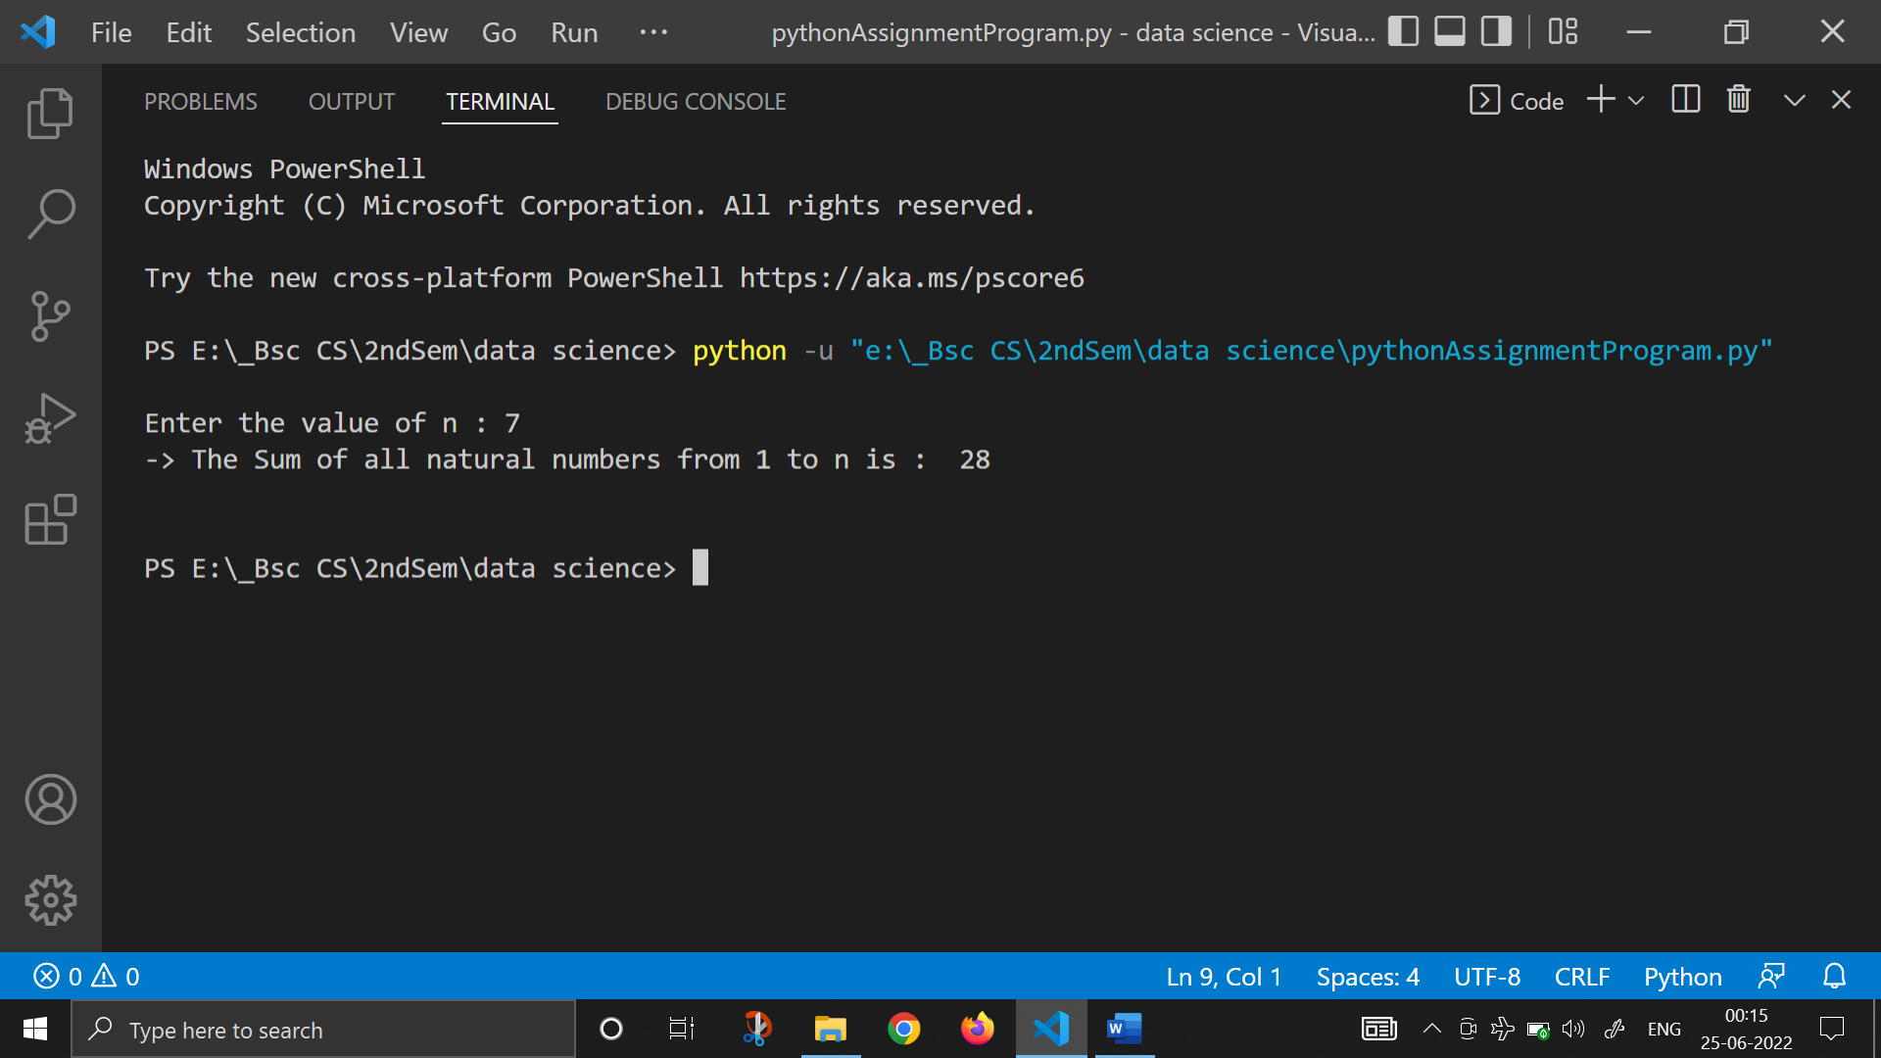

1. [**Write a program to find sum of all even numbers between 1 to n**](https://codeforwin.org/2015/06/c-program-to-print-sum-of-all-even-numbers-between-1-to-n.html)**.**

n=int(input("Enter the value of n : "))

sum=0

i=1

while (i<=n):

    if (i%2==0):

        sum+=i

    i+=1

print("-> The Sum of all even numbers from 1 to n is : ", sum)

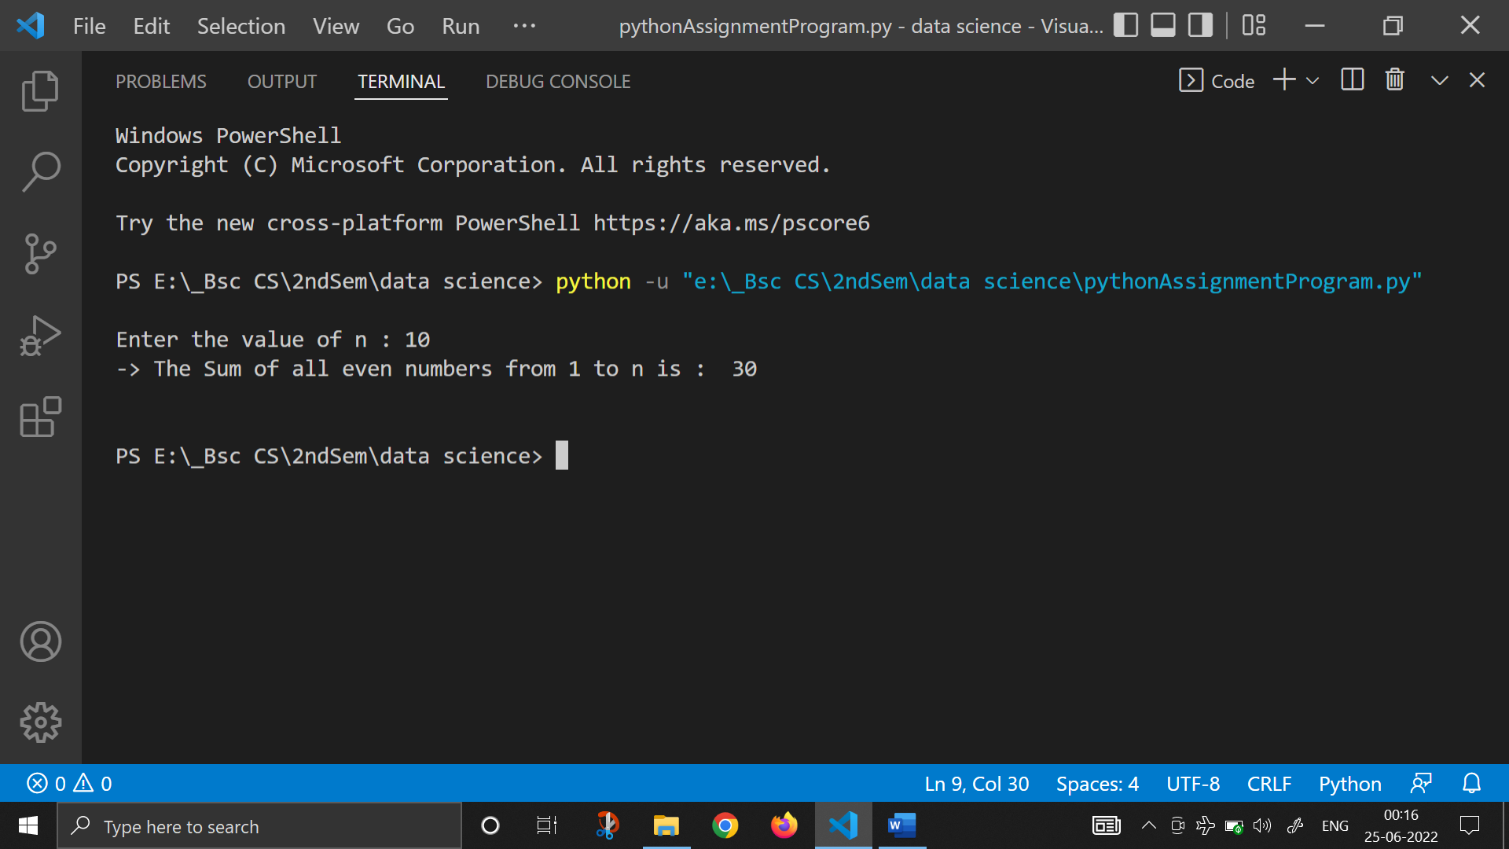

1. [**Write a program to find sum of all odd numbers between 1 to n**](https://codeforwin.org/2015/06/c-program-to-print-sum-of-all-odd-numbers-between-1-to-n.html)**.**

n=int(input("Enter the value of n : "))

sum=0

i=1

while (i<=n):

    if (i%2!=0):

        sum+=i

    i+=1

print("-> The Sum of all odd numbers from 1 to n is : ", sum)

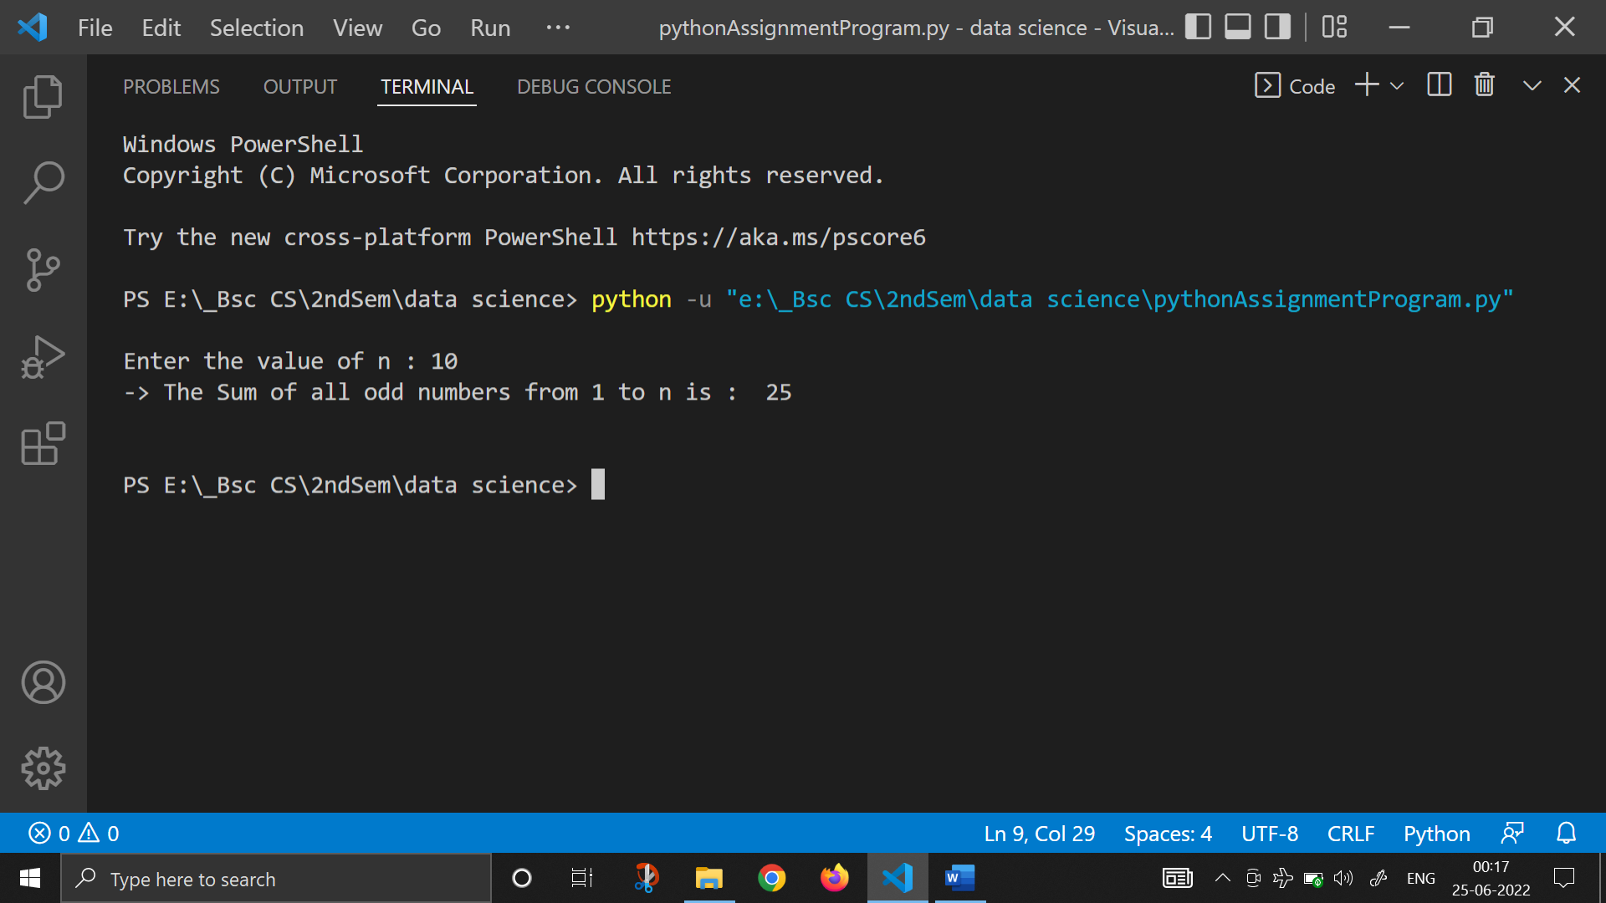

1. [**Write a program to print multiplication table of any number**](https://codeforwin.org/2015/06/c-program-to-print-table-of-any-number.html)**.**

print()

n=int(input("Enter the value of n : "))

print("-> The Table of ", n , " : ")

for i in range(1, 11):

    print(n," * ",i," = ",n*i)

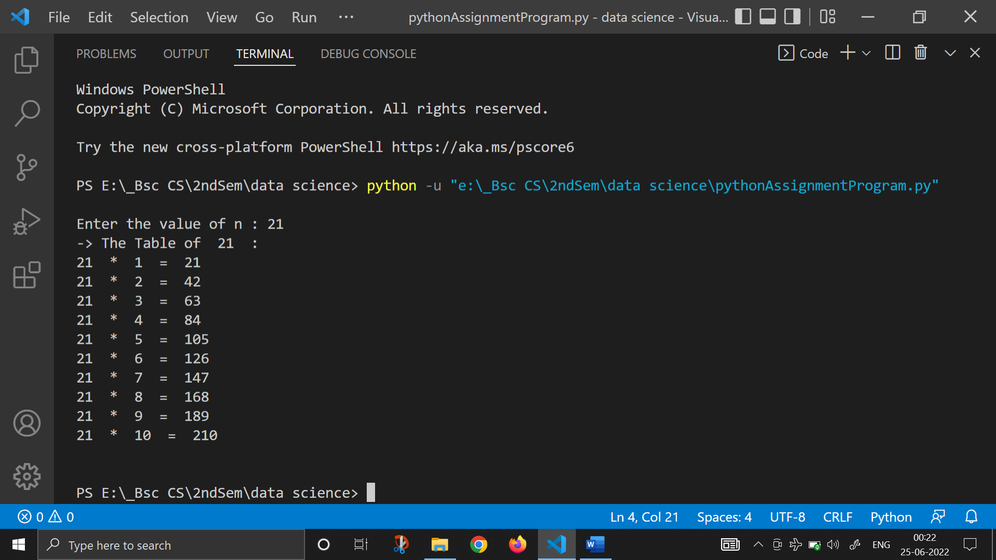

1. [**Write a program to count number of digits in a number**](https://codeforwin.org/2016/10/c-program-to-count-number-of-digits-in-number.html)**.**
2. [**Write a program to find first and last digit of a number**](https://codeforwin.org/2015/06/how-to-find-first-and-last-digit-of-any-number.html)**.**
3. [**Write a program to find sum of first and last digit of a number.**](https://codeforwin.org/2015/06/c-program-to-find-sum-of-first-and-last-digit-of-number.html)
4. [**Write a program to swap first and last digits of a number**](https://codeforwin.org/2016/01/c-program-to-swap-first-and-last-digit-of-number.html)**.**
5. [**Write a program to calculate sum of digits of a number**](https://codeforwin.org/2015/06/c-program-to-calculate-sum-of-digits.html)**.**
6. [**Write a program to calculate product of digits of a number**](https://codeforwin.org/2015/06/c-program-to-calculate-product-of-digits.html)**.**
7. [**Write a program to enter a number and print its reverse**](https://codeforwin.org/2015/06/c-program-to-find-reverse-of-any-number.html)**.**
8. [**Write a program to check whether a number is palindrome or not.**](https://codeforwin.org/2015/06/c-program-to-check-whether-number-is-palindrome-or-not.html)
9. [**Write a program to find frequency of each digit in a given integer**](https://codeforwin.org/2016/10/c-program-to-count-frequency-of-digits-in-number.html)**.**
10. [**Write a program to enter a number and print it in words.**](https://codeforwin.org/2015/06/c-program-to-print-numbers-in-words.html)
11. [**Write a program to print all ASCII character with their values**](https://codeforwin.org/2015/06/c-program-to-print-ascii-values-of-all-characters.html)**.**
12. [**Write a program to find power of a number using for loop**](https://codeforwin.org/2015/07/c-program-to-find-power-of-number-using-for-loop.html)**.**
13. [**Write a program to find all factors of a number**](https://codeforwin.org/2015/06/c-program-to-print-factors-of-any-number.html)**.**
14. [**Write a program to calculate factorial of a number**](https://codeforwin.org/2015/06/c-program-to-calculate-factorial-of-any-number.html)**.**
15. [**Write a program to find HCF (GCD) of two numbers**](https://codeforwin.org/2015/06/c-program-to-find-hcf-of-two-numbers.html)**.**
16. [**Write a program to find LCM of two numbers**](https://codeforwin.org/2015/06/c-program-to-find-lcm-of-two-numbers.html)**.**
17. [**Write a program to check whether a number is Prime number or not.**](https://codeforwin.org/2015/06/c-program-to-check-prime-number.html)
18. [**Write a program to print all Prime numbers between 1 to n.**](https://codeforwin.org/2015/06/c-program-to-print-all-prime-numbers-between-1-to-n.html)
19. [**Write a program to find sum of all prime numbers between 1 to n**](https://codeforwin.org/2015/06/c-program-to-find-sum-of-all-prime.html)**.**
20. [**Write a program to find all prime factors of a number**](https://codeforwin.org/2015/06/c-program-to-find-all-prime-factors-of-any-number.html)**.**
21. [**Write a program to check whether a number is Armstrong number or not.**](https://codeforwin.org/2015/06/c-program-to-check-armstrong-number.html)
22. [**Write a program to print all Armstrong numbers between 1 to n.**](https://codeforwin.org/2015/06/c-program-to-print-first-n-armstrong-numbers.html)
23. [**Write a program to check whether a number is Perfect number or not**](https://codeforwin.org/2015/06/c-program-to-check-perfect-number.html)**.**
24. [**Write a program to print all Perfect numbers between 1 to n**](https://codeforwin.org/2015/06/c-program-to-print-all-perfect-numbers-between-1-to-n.html)**.**
25. [**Write a program to check whether a number is Strong number or not**](https://codeforwin.org/2015/06/c-program-to-check-strong-number.html)**.**
26. [**Write a program to print all Strong numbers between 1 to n**](https://codeforwin.org/2015/06/c-program-to-print-all-strong-numbers.html)**.**
27. [**Write a program to print Fibonacci series up to n terms**](https://codeforwin.org/2015/06/fibonacci-series-in-c-program.html)**.**
28. [**Write a program to print Pascal triangle upto n rows**](https://codeforwin.org/2015/07/c-program-to-print-pascal-triangle.html)**.**